MISSION

NASA’s Juno mission is to deepen the knowledge of how we, as human beings, came to existence by studying the origin and structure of the largest and possibly oldest planet in our solar system – Jupiter (Perez, 2016).

Jupiter is the largest planet in our solar system. It is among the brightest objects that appears in the night sky. It has four moons. Scientists believe this planet moved around throughout the solar system in its youth, instead of remaining in the same spot as it is now. Before Juno, numerous of spacecrafts were sent to study this mysterious giant, including but not limited to the Pioneer 10 and 11, Voyager 1 and 2, Galileo, Ulysses, Cassini, and Hubble Space Telescope. Early findings about Jupiter in 1970s concluded that it is composed mostly of liquid. Like Earth, it has magnetic field which suggesting that it might have a solid core in its composition. Scientists also found the presence of active volcanoes on the surface of one of Jupiter’s moons, Io. It is observed to be about 36 volcanoes. They found to be similar to those we have on Earth in term of lava temperature. Scientists also discovered that weather on Jupiter has similar characteristics to that of Earth. It has lightning in the cloud tops and hurricane-like storms (Morrow, 2016).

With Juno’s successful arrival in July 2016, scientists expected to collect information on Jupiter’s atmosphere, and magnetic and gravitational fields. The information, thus, will provide an insight of the planet’s structure for a better understanding of its origin and evolution. This information could also hint clues about the origins and formation of our solar system (Morrow, 2016).

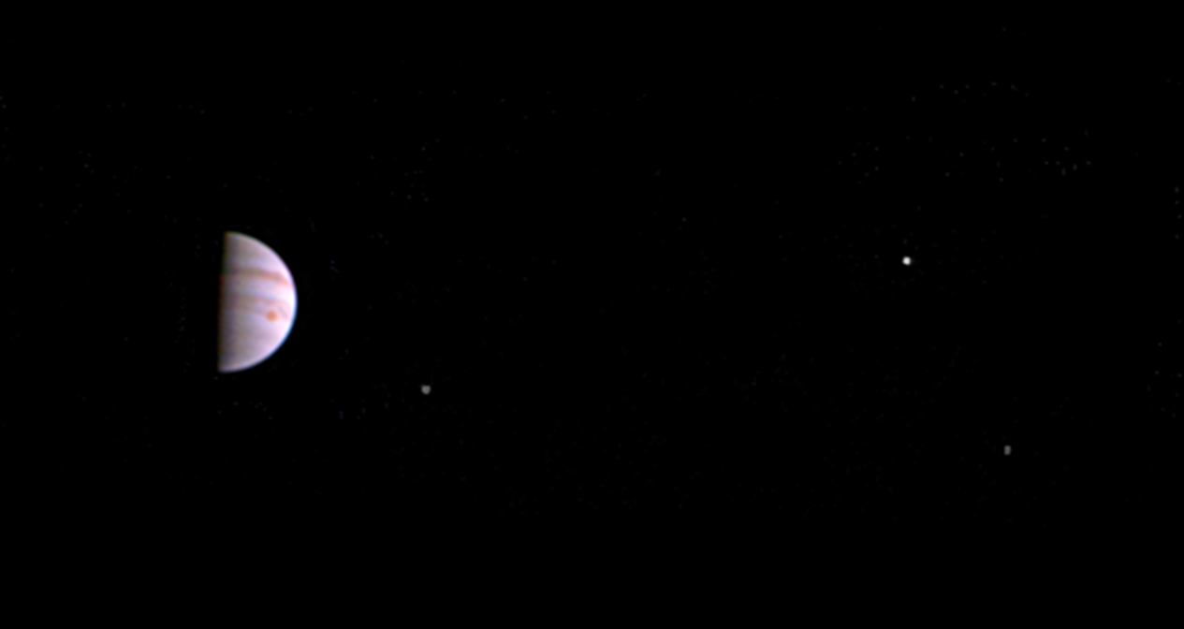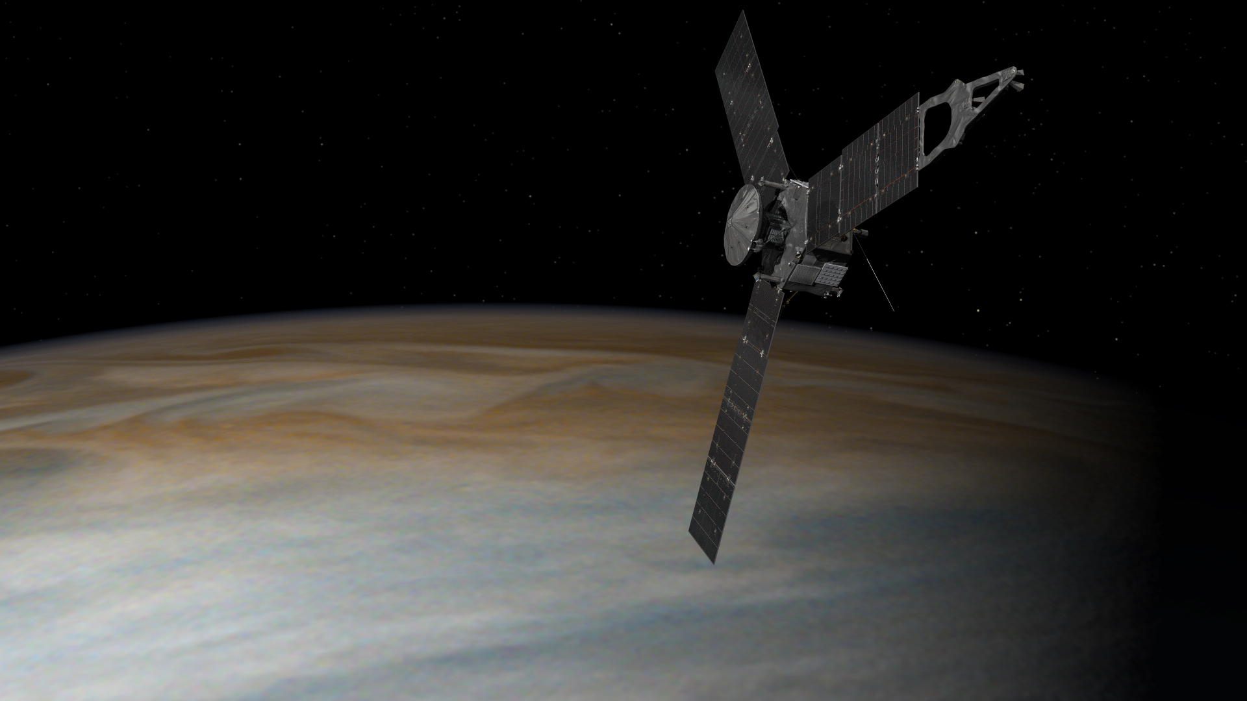

SPACECRAFT STRUCTURE

Juno uses a rotating, solar-powered spacecraft to provide extreme stability while offer an ease of control. Its rotation rate varies throughout the mission. It uses 1 RPM for cruise, 2 RPM for science operations, and 5 RPM for main engine maneuvers. While in orbit at Jupiter, with two rotations per minute, it takes about two hours (equivalent to 240 rotations) for Juno to fly from one pole to another (“Spacecraft,” n.d.).

The main body of this spacecraft is in a hexagon shape that has a two-deck structure. It is 11.5 feet (3.5 meters) tall and 11.5 feet (3.5 meters) in diameter. To protect Juno in a heavy radiation environment for a sustained exploration, it is equipped with the first-of-its-kind radiation-shielded electronics vault. This vault is about the size of an SUV’s truck. It houses Juno’s command and date handling box, power and data distribution unit, and about 20 other electronic assemblies. The entire unit weighs about 400 pounds, approximately 200 kilograms. This spacecraft runs on solar power. It is generated by three arrays consisting of 11 solar panels. The surface area of these solar panels are required to be very large because Jupiter is about five times farther from the sun than Earth. It means it will receive less sunlight as it gets closer to Jupiter’s orbit. Therefore, it needs larger panels in order to generate enough energy to operate. These three arrays of solar panels extend outward from Juno’s main body, which gives the spacecraft an overall length of more than 66 feet (20 meters) (“Spacecraft,” n.d.).

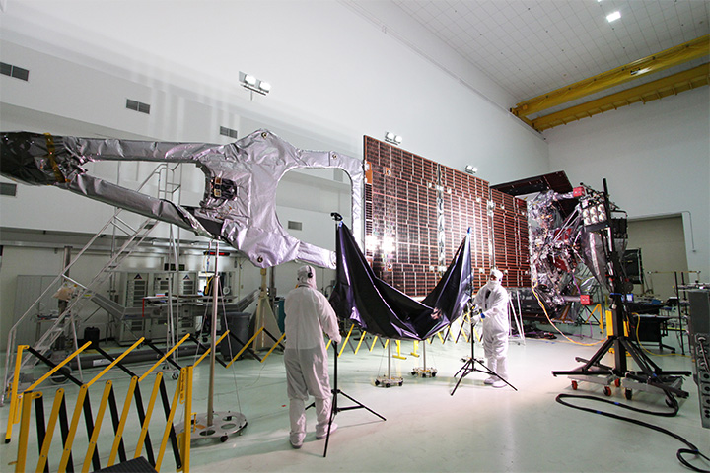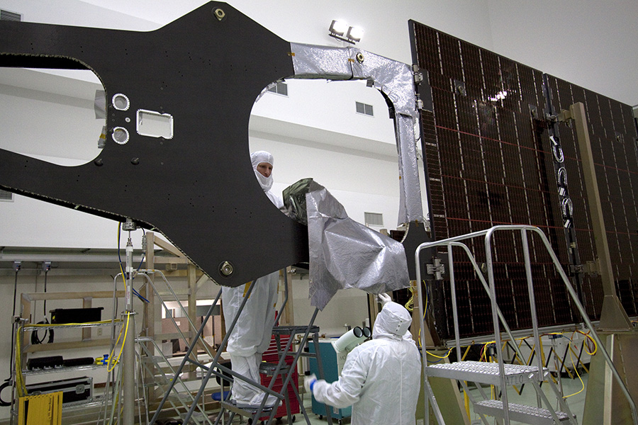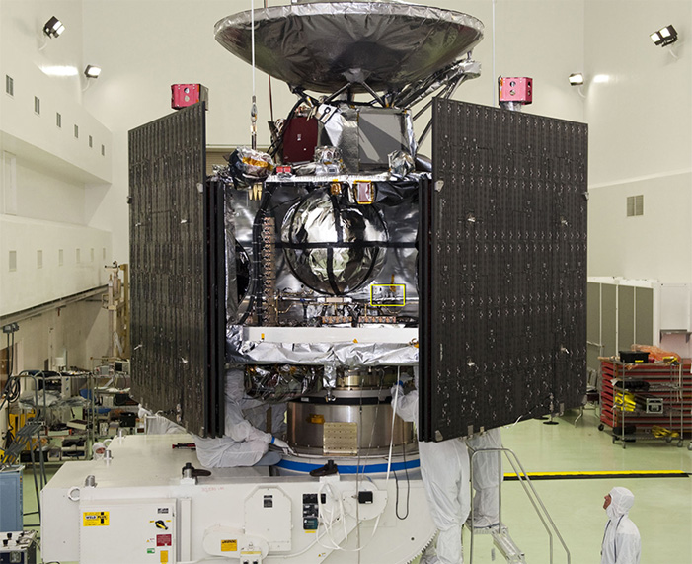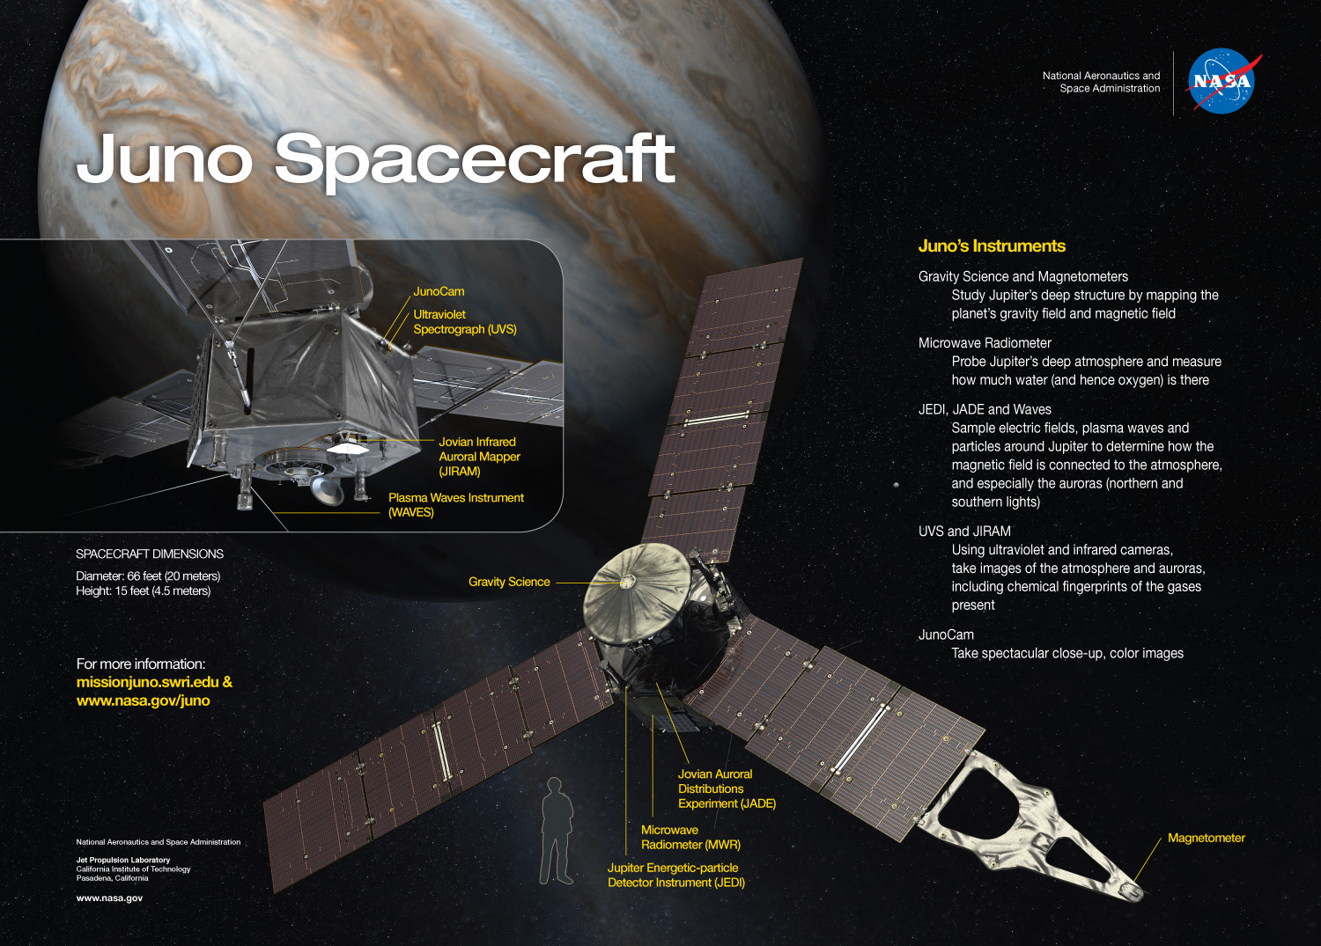

ORBITING

After a month into orbit, Juno will reach the farthest point in its orbit – approximately 5 million miles (8.1 million kilometers) from Jupiter on July 31th, 2016. After this point, it will circle back toward the planet for another pass. This turn is caused by Jupiter’s gravitational grip on Juno. This orbit is referred to as Capture Orbit. It is 53.5 days long. After the first of two Capture Orbit, Juno will perform a series of 14-day orbits for its science mission (Greicius, 2016b).

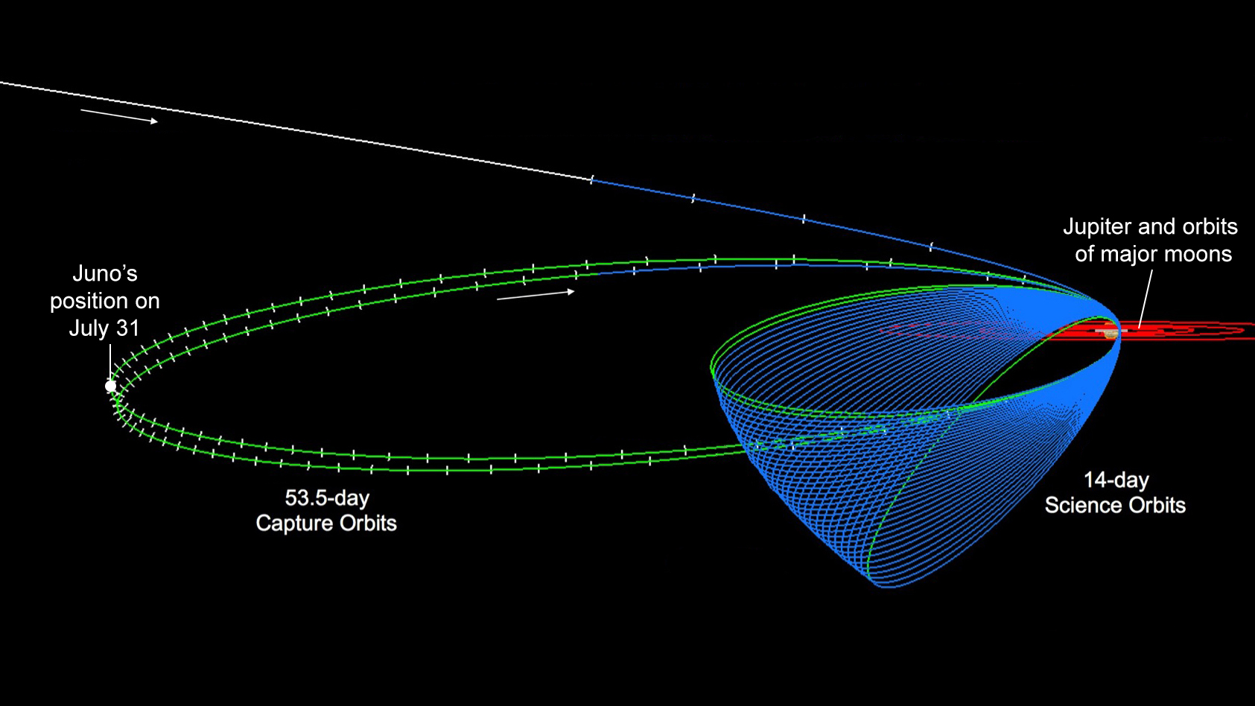

NORTH POLE

For the first time ever, Juno has sent back images that reveal Jupiter’s north and south poles during its first flyby with the instruments switched on. The images captured storm systems and weather activities that we have not seen on any gas-giant planets in our solar system. These images are impossible to be seen from Earth.

According to Scott Bolton, principal investigator of Juno from the Southwest Research Institution in San Antonio, he stated that the color of the north pole is bluer comparing to other parts and there are also a lot of storms happening. There is no latitudinal bands or zone and belts in this region. He also suggested that the clouds are probably higher in altitude due to the visible shadows of the clouds.

Scientists also had a close-up view of Jupiter’s south pole under infrared light to analyze the warm and hot spot underneath the skin of this planet. We have not seen able to see the southern auroras ever before, both from Earth or space. Images sent back from Juno suggested that the south pole is very bright and well-structured. This tell scientists more information about the morphology and dynamics on the aurora in Jupiter’s south pole.

Sound waves captured from the north pole reveals emissions of energetic particles that generate massive auroras in this region. These emissions are believed to be the strongest in the solar system. Scientists are investigating the electron source that are generating these emissions (Greicius, 2016c).

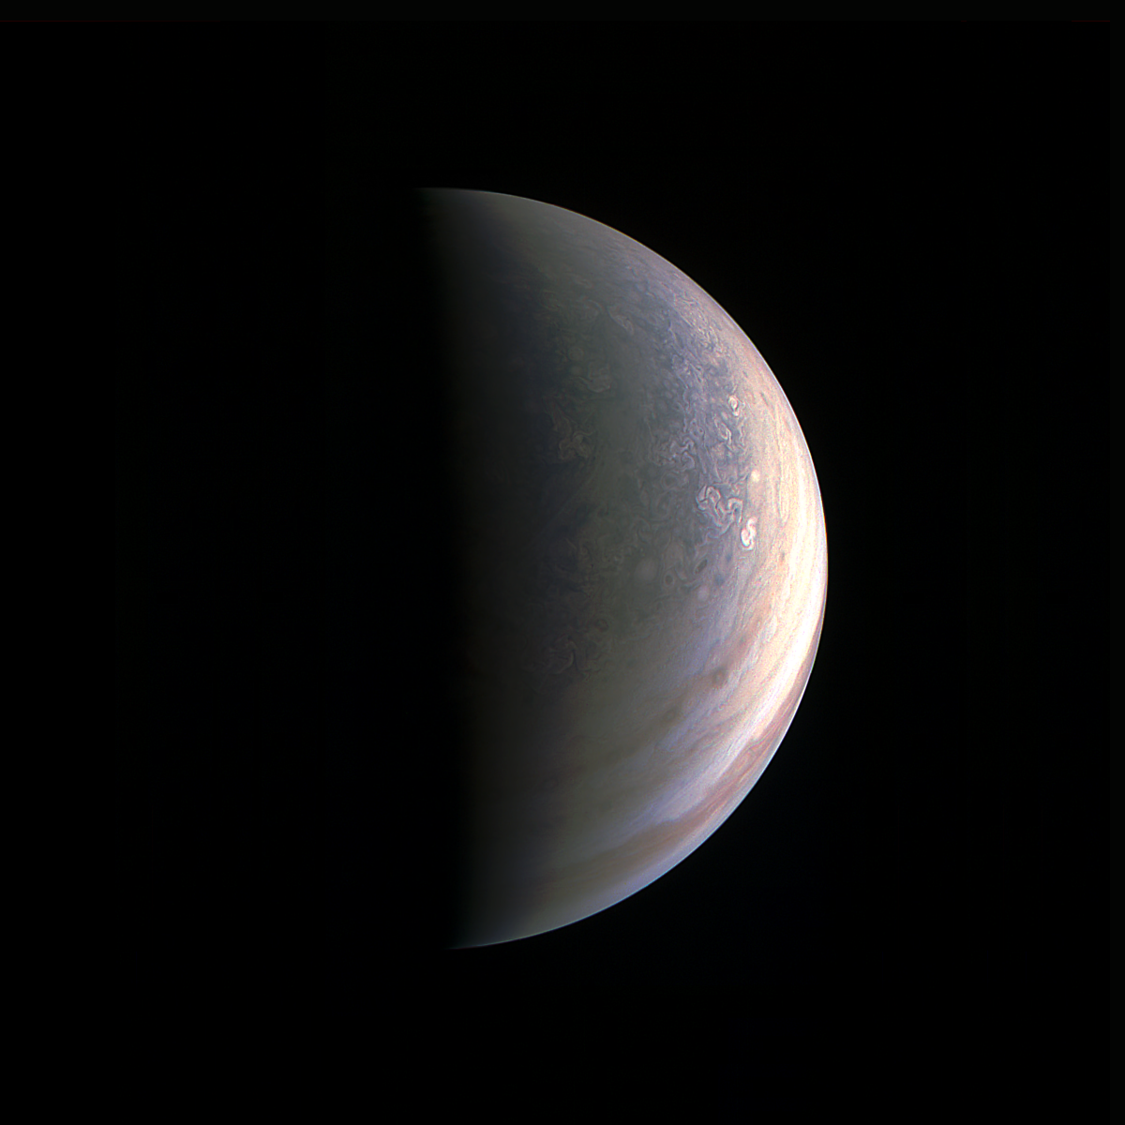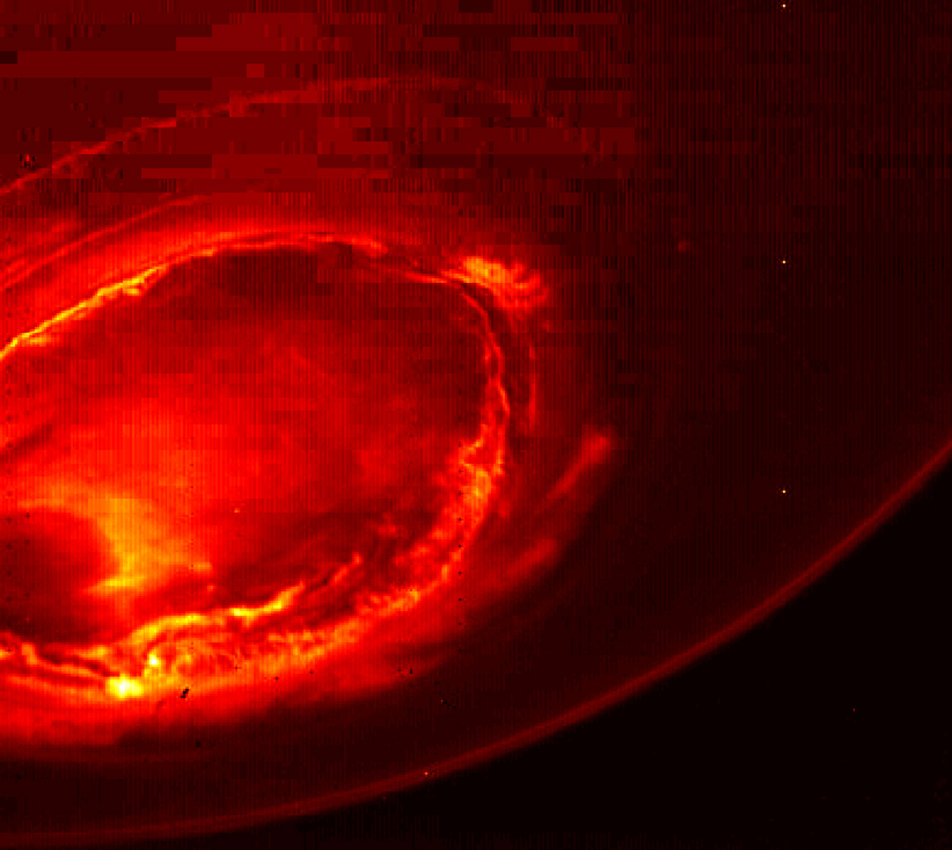

Media

Juno Rotation Speed Animation (“Spacecraft,” n.d.)

Juno Capture the ‘Roar’ of Jupiter (Greicius, 2016a)

Juno Listens to Jupiter’s Auroras (Greicius, 2016c)

Juno’s Glow in Infrared Light (Greicius, 2016c)

Bibliography

Greicius, T. (2016, July 1). *NANA’s Juno Spacecraft Jupiter’s Magnetic Field*. Retrieved August 29, 2016, from NASA, http://www.nasa.gov/feature/jpl/nasas-juno-spacecraft-enters-jupiters-magnetic-field. (a)

Greicius, T. (2016, July 28). *Five years post-launch, Juno is at a turning point*. Retrieved August 29, 2016, from NASA, http://www.nasa.gov/feature/jpl/five-years-post-launch-juno-is-at-a-turning-point. (b)

Greicius, T. (2016, September 2). *Jupiter’s north pole unlike anything encountered in solar system*. Retrieved September 4, 2016, from NASA, http://www.nasa.gov/feature/jpl/jupiter-s-north-pole-unlike-anything-encountered-in-solar-system/. (c)

Morrow, A. (2016, August 5). *Decades of discovery: NASA’s exploration of Jupiter*. Retrieved August 29, 2016, from NASA, http://www.nasa.gov/feature/goddard/2016/decades-of-discovery-nasa-s-exploration-of-jupiter.

*Spacecraft*. (n.d.). Retrieved August 29, 2016, from NASA Jet Propulsion Laboratory: California Institution of Technology, http://www.jpl.nasa.gov/news/press_kits/juno/spacecraft/.

Perez, M. (2016, July 15). *NASA sails full-speed ahead in solar system exploration*. Retrieved August 29, 2016, from NASA, https://www.nasa.gov/feature/nasa-sails-full-speed-ahead-in-solar-system-exploration.